Japanese animated adaptation of   
Nisoisin’s *Katanagatari*

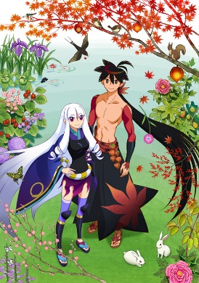

**Why Episode 12 is a success**

Cody Strange

Professor J. Matthew Clarke

English 1010

September 29, 2020

# Introduction

As one of or not the most underrated anime of its time, NisiOisiN’s *Katanagatari* is often overlooked by most viewers for NisiOisiN’s more popular works such as *Monagatari*. Even so it is one of the greatest anime of all time. Its episode 12 was a great success and for the following reasons, its complex dialogue, unique art style, and unorthodox theme. It is a gem that is often overlooked but given the chance everyone should give it a watch. It is a one of a kind that you won’t find anything quite like it.

# Background

Nishio Ishin, stylized NisiOisiN to emphasize the palindrome, is the pen name of the writer of *Katanagatari*. Born in Japan of 1981 Nishio Ishin attended the Ritsumeikan University College of Policy Science to study art to become a mangaka. He would eventually drop out from lack of noticeable improvement in his drawing ability, and he decided to become a novelist instead. Nishio Ishin made his debut with the novel Kubikiri cycle, which got him the 23rd Mephisto Award at the age of twenty. He is most famous for his extremely popular Monogatari, and many of his other works fell into the shadow of his twenty-four-book series hit. Katanagatari, was written in 2007 and starting in January came out as a twelve light novel series with one light novel being released each month. The way that the series was released would have some correlation with the story inside the series. The light novels in 2010 would come to be adapted into an anime by White Fox co. The anime was unique in the fact that each episode was fifty minutes long, twice the average length. And in mirroring the light novels would be released one episode per month.

*Katanagatari* takes place in the Edo era of Japan. It follows the story of the self-proclaimed “strategist” Togame, who was charged by the Shogun with retrieving the twelve deviant swords created by the legendary swordsmith Shikzaki Kiki from over a hundred years ago. Togame, needed help from someone who could defeat the current owners of the swords. So she traveled to an isolated island to meet the 7th generation heir of the Kyotouryuutechnique, Yasuri Shichika. Shichika’s Kyotouryuusword technique doesn’t allow for the user to wield a sword; therefore Shichika was the perfect candidate for Togame. He was someone strong enough to gain control of the swords, but he couldn’t use them. Upon meeting, Shichika asks Togame why he would join her, and she responds with, “I’ll make you fall for me.” A little while later as Togame is about to be slain by a ninja that followed her to the island, and she is saved by Shichika. When she asks him why he responds completely stone-faced, “I have fallen for you.” Just like that their adventure begins.

Episode twelve starts after they have collected eleven of the twelve swords and return to the capital. There they meet by Togame’s rival Princess Hite’s servant, Emonzaemon who holds the last sword, a pair of pistols named Ento Jyo.

**Analysis**

The first reason why *Katanagatari* is a success is itscomplex dialogue. It shows Togame’s inner turmoil and the development she went through in twelve-minutes, while not boring the audience. Within the first minute of episode Togame gets shot by Emonzaemon and she soon realizes that she is going to die. She decides to use the last of her precious time to speak with Shichika, and to reveal the truth about herself and her goals. Togame starts the conversation by abruptly asking Shichika if as her dying wish he could make the country pick up her catchphrase “Cheerio!” A word that she has been using incorrectly for most of the show. Shichika asks how he could do something as ridiculous as that by himself. It’s this kind of dry humor in such an emotional moment that adds new layers to the dialogue in Katanagatari. Togame is using this to transition into telling Shichika that he needs to move on without her. Shichika argues that he can’t do anything without her. Togame shakes her head, saying he no longer needs to rely on her anymore.She tells Shichika that he has taught her how a person should live; she says that she has learned so much from him. This is surprising because at a surface level you would expect it to be the other way around, Shichika was the one who started out as an emotionless weapon. He was the one who learned from Togame what it meant to be a human, what we never got to see was how Togame was changing on the inside. She was changing without the knowledge of anyone because no one even knew she needed to change, she was just that good at hiding herself. This little monologue is showing us how without our knowledge Togame changed as much as Shichika had. It gives us a hint as to the kind of person she was as she worked alone for twenty years. It is also during this piece that her voice begins to crack, her normal stoic tone giving way to the emotion that she feels. She is claims that in the end she hadn’t really changed at all, and that this was a fitting way for her to die. Her voice is betraying her as she sounds as if she is about to break out into tears, the idea of dying without ever really changing terrifies her. After this momentary period of weakness, she regains her composure, and her left pupil changes into a cross. This occurs when she gets into her “scheming” mode, and she reveals her true intentions to him. That once they had collected all twelve swords, she was going to kill him. Shichika’s father was the warrior who killed Togame’s father and that was not something she could forgive him for. Everything was nothing more than a tool for her, she even used her own emotions as a tool to reach her end goal. Collecting the swords, gaining an audience with the Shogun, killing the shogun, and then killing Shichika. Togame’s scheming eye could be taken to mean two different things here. One, this was one of her schemes, to try and get Shichika to be able to move on from her. Two, this was her revealing her grand scheme to Shichika, having no reason to keep him in the dark any longer. I believe the answer is a mixture of these two. Togame isn’t such a black or white character for it to be this simple. I believe her original plan was to kill Shichika and to use her feelings as a tool to be able to convince him that she loved him. I also think she underestimated how much she would come to love him. I think if her life wasn’t taken by Emonzaemon she would’ve killed Shichika in the end. She would have hated herself for it, but she would be so caught up in her schemes that she would believe she needed to kill him, even if she really loved him. Shichika was willing to throw his life away if Togame had simply asked him to. He didn’t understand why she would cause herself so much pain by tricking herself and everyone around her. This continues to show the constant turmoil that has been taking place in Togame’s mind, between completing her schemes and her love for Shichika. In the end, dying, with her revenge having failed, Togame is happy. She is over joyous with the knowledge that she won’t ever have to kill Shichika. She knew that had the time come, she would have pushed herself to complete her scheme that she had devoted too much of herself to. Togame acknowledges all the wrong she has done in the life, and that she has been using Shichika as a tool. She spent so much of her life in her schemes and plots for revenge that she believed there was nothing left for her. But even with all the scheming she had done, with her last breath all she wanted was to know if she could still be allowed to love Shichika. This ending is a nostalgic throwback to the first episode twelve months prior when Togame proclaimed that she would gain the warrior Shichika’s help by making him fall for her. It’s this kind of dialogue that makes you need to sit down and just think about life, what it really means to love someone, and the consequences your obsessions can create. This is one of the major reasons that *Katanagatari* episode 12 was so successful.

The second reason why *Katanagatari* is a success is itsunique art style. Pausing at nearly any moment in *Katanagatari* could give you a painting worthy of framing onto a wall. The characters are simply drawn, using minimal lines and bold strokes to make the characters pop out in the finer detailed backgrounds. Each character in *Katanagatari* is uniquely drawn with their own set of colors, different characters are also given differing variety of colors. Togame has of seventeen instances of colors and shades that create her clothes and character. Each of these colors are bold and well defined, none of the repeating colors are part of the same article. Each color has its own designated area cover and none of them cross into the territory of another’s color. Shichika on the other hand wears much more plain clothes with only a few instances of color. He lacks any upper body clothes beyond some sleeves that appear to be painted onto him rather than being worn by him.

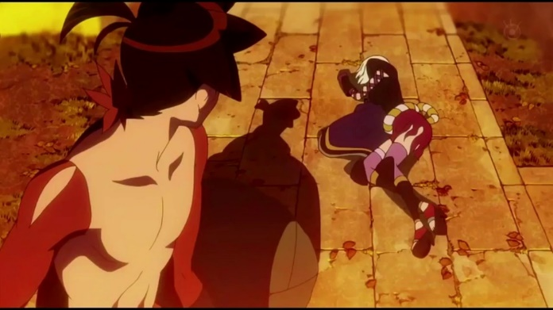These colors represent the complexity of *Katanagatari*’s characters. Togame has multiple personalities, from being a clumsy love-stricken girl, to a cold-blooded strategist willing to do anything to win. Like the colors represent, Shichika has a much simpler character. While he does develop change over the course of the anime, he is never swapping between personalities like Togame.

*Togame Collapsing after being shot by Emonzaemon*

The backgrounds are taken with a more detailed approach, finer lines and increased shading give a sharp contrast from the basic approach to the character designs. The background often acts as a backdrop for the main characters. While Togame and Shichika interact with each other they rarely interact with the world around them. The setting will remain motionless, trees don’t sway, ships don’t move. The world seems to be frozen in time until it is directly interacted with by whoever is the lead for the scene.

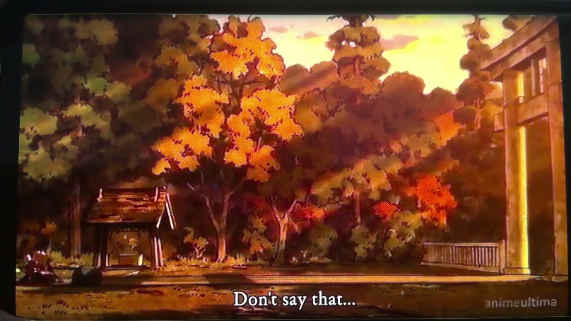This is what gives the episode many beautiful scenes that closer resemble a painting than an animated series. For example, when Togame is having her bought of dialogue with Shichika moments before she dies the camera zooms out and does a panning shot of the scenario around them. There is a thick forest in the background, the autumn leaves are starting to change from green to yellow and red. You can tell that it is dusk from the lighting that the sun is giving off. It’s not bright as if it were midday, rather the sunlight is a shade darker than usual, an effect that only occurs as the sun is setting. This sunlight adds an extra layer of detail and shadows onto the scene that wouldn’t otherwise be there. The yellow leaves are reflecting off a golden sheen from the angle that the sunlight is landing. The stone gateway and wooden well let you know that they are the entrance of a city. You must look closely to even notice that Shichika is holding Togame in the bottom left corner. The purpose of this shot isn’t to show the characters but the background that surrounds them.

*Togame telling Shichika that he needs to “move on” without her*

It’s this kind of artistic style that makes the episode not only have beautiful dialogue but stunning visuals as well. Theses visuals are another major reason why *Katanagatari Episode 12* is a success.

The third reason why *Katanagatari* is a success is unorthodox theme. Just like to the dialogue and art style, the theme of *Katanagatari* is unique. The theme that the episode 12 presents is this, “A story that come to nothing is still a story worth telling.” Togame’s ambitions, schemes and goals were all cut short when she took a bullet to the stomach from Emonzaemon. The eleven episodes of buildup were all ended in the blink of an eye. *Katanagatari* once again showed that the world was a cruel place and no one, not even a main character was safe. Togame never got the chance to finish out her revenge plot or to truly change herself into someone worthy to love Shichika. All she could do was ask Shichika for forgiveness as she died. Shichika in turn lost his one purpose to live, the one thing that he had devoted his life to was now gone. Though Togame asked him to live for himself and to move on from her, it wasn’t something he could do. With Togame dead he didn’t see the need to follow her orders anymore and he stormed the Shogun’s castle with one intention in mind, dying. Though Shichika found himself simply too powerful to die, no matter how many guards came at him he destroyed all of them. Upon arriving the thirteen-floor building that was the Shogun’s house, Shichika found himself greeted by eleven of the Shogun’s retainers. Each had in their possession one of the Deviant Blades that Shichika and Togame had worked so hard to collect. What follows is one of the most painful set of scenes to watch, Shichika fights each of the retainers one-by-one and he shatters every blade in each fight. The last remnants of the time Shichika and Togame spent together, their hard-won rewards being obliterated by the very man who swore to protect them. Everything the previous eleven episodes had been spent on, being wasted away, proving that Shichika’s and Togame’s adventure was all but pointless. By the time Shichika reaches the twelfth floor, all that’s left is the pair of swords wielded by Emonzaemon. Shichika fights him, not to take revenge upon Togame, but because he believed only the one who killed Togame could be the one to kill himself. Shichika’s plans are once again ruined when he successfully kills off Emonzaemon, destroying the last pair of swords, and his last hope at death. He walks up to the last floor, bloody and scarred from his fight with Emonzaemon and angry at the whole situation. On the final floor are two people, the Shogun and Princess Hitei. Here Princess Hitei explains that her great ancestor Shikzaki Kiki, the creator of the twelve swords, was a powerful seer. He foresaw the future of Japan being destroyed from invaders and created the twelve swords to change the future by setting everything that is currently happening into motion. He needed the current Shogun to die so a new, more powerful dynasty could arise and protect Japan when the time arouse. Everything that has happened until know was all according to Shikzaki Kiki plans. All that was left was for Shichika to kill the Shogun, and Shichika in all his rage did just that. In the end the Shogun’s son would take over and the current dynasty would continue to rule. Shikzaki Kiki plans would ultimately fail and it would have nothing to do with any of the main characters, just simply Shikzaki Kiki not accounting for one small detail. This means that by the end of the story Shikzaki’s plans failed, Togame’s plans failed, Princess Hitei’s plans failed. And to top it all off, the entire adventure was pointless, with the twelve blades being destroyed in the end. There is just one more scene in the anime before it ends. Shichika is on the side of the road eating some dumplings and being followed by Princess Hitei. He has a scar on his face from the fight from Emonzaemon but looks otherwise in great condition, both physically and mentally. He has decided that he wants to create the first map of all of Japan, something he and Togame talked about doing once they finished up their sword mission. It’s this last scene that truly brings the theme together, even though it was all for naught Shichika proved that he was able to move on. He was able to change and prove that even a story that doesn’t lead to anything is still a story worth telling, and a story that someone can learn from.

**Opposition**

There are some people who may disagree with my opinion on *Katanagatari Episode 12.* They will argue that the ending was disappointing and that because the story didn’t go anywhere it wasn’t one worth telling. I feel like they missed the point of the anime, the whole theme of the anime was that even though everyone’s plans failed and almost everyone died the story is worth telling. The story is about the improvement Shichika was able to make as a person even as everything fell apart all around him. It’s about how sometimes life doesn’t go your way, but life still moves on.

**Conclusion**

To finish up, *Katanagatari Episode 12* was a success for the following reasons, the complex dialogue, the unique art style, and the unorthodox theme. This series isn’t for everyone, the dialogue is rather wordy, the art style isn’t normal, and the theme is very hit-or-miss. It’s the things that make the series so good for some that make it so bad for others. And this episode in particular can be very polarizing, but I still think it is worth the watch no matter who you are. The show is very original in its execution and you won’t find another one like it. For anyone who has the opportunity to watch it I will recommend it 100% of the time.

References

Last Name, F. M. (Year). Article Title. *Journal Title*, Pages From - To.

Last Name, F. M. (Year). *Book Title.* City Name: Publisher Name.